**https://www.worldbank.org/en/country/turkey/brief/turkeys-improvements-in-the-quality-of-learning**

**BRIEF JANUARY 21, 2021**

**Turkey’s Improvements in the Quality of Learning: TIMMS 2019 Results**

Turkey has made considerable improvements in quality of learning, based on math and science test scores among its students in grades 4 and 8. This has been confirmed by the 2019 [Trends in International Mathematics and Science Study](https://timss2019.org/reports/wp-content/themes/timssandpirls/download-center/TIMSS-2019-International-Results-in-Mathematics-and-Science.pdf) (TIMSS), which covered 64 countries around the world. It also increased the proportion of students reaching high and advanced international benchmarks. Such progress can be attributed to Turkey’s commitments to increasing the quality and equity of education - along with building on previous gains in schooling access. Some of the proposed educational goals and reforms are included in three key national development plans: [Turkey’s Education Vision 2023](https://2023vizyonu.meb.gov.tr/doc/2023_VIZYON_ENG.pdf), [Eleventh Development Plan 2019-2023](https://www.sbb.gov.tr/wp-content/uploads/2019/11/ON_BIRINCI_KALKINMA-PLANI_2019-2023.pdf) and [Education Strategy Plan 2019-2023.](http://sgb.meb.gov.tr/meb_iys_dosyalar/2019_12/31105532_Milli_EYitim_BakanlYYY_2019-2023_Stratejik_PlanY__31.12.pdf)

Turkey participated in TIMMS assessments in 1999, 2007, 2011, 2015 and 2019. Both math and science show ongoing improvement (see Figure 1) and average scores have increased in all regions except the Western Black Sea region, which showed limited increase in science for fourth graders.

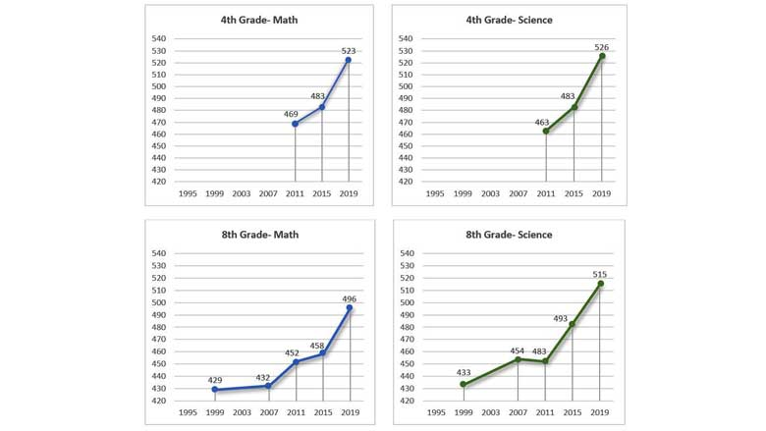

**Turkey’s 2019 International and within EU Performance in Math**

At the fourth-grade level, within all participants, Turkey outperformed 28 countries – including the Slovak Republic, Croatia, Spain and France. Turkey performed lower than 17 countries - including Ireland, Latvia, Lithuania, Austria, Netherlands, Czech Republic and Belgium. Those countries that performed similar to Turkey included Cyprus, Finland, Portugal, Denmark, Hungary, Sweden, Germany, Poland, Bulgaria, and Italy.

At the eighth-grade level, Turkey performed better than 18 countries overall - including France and Romania. Turkey performed lower than 14 countries- including Ireland, Lithuania, Hungary, and Finland. Participants from EU countries performing at a similar level to Turkey included Sweden, Cyprus, Portugal, and Italy.

**Turkey’s 2019 International and within EU Performance in Science**

At the fourth-grade level, out of 58 countries, Turkey performed significantly higher than 29 countries, including Cyprus, Spain, Italy, Portugal, Belgium (Flemish Region), and France. Turkey performed lower than 12 countries, including Finland, Latvia, Lithuania, and Sweden. EU countries with similar performance levels as Turkey are the Czech Republic, Poland, Hungary, Ireland, Croatia, Denmark, Austria, Bulgaria, Slovak Republic, Netherlands, and Germany.

At the eighth grade-level, out of 39 countries, Turkey performed better than 22 countries, including Italy, France, Cyprus, and Romania. Turkey's science performance is lower than 9 countries, including Finland, Lithuania, and Hungary. EU countries that perform at the same level as Turkey are Ireland, Sweden, and Portugal.

**What explains Turkey’s learning improvements?**

A detailed analysis is planned to identify key interventions that explain Turkey’s learning improvements. So far, attributed factors by the [Ministry of National Education](https://www.youtube.com/watch?v=KnegALVPrro) include investments in teacher training, e-learning support, assessment reforms, and inclusion of 21st century/modern skills in all K-12 curriculum.

TIMMS also collected preliminary data on other home and school factors which may contribute to learning improvements. For Turkey, these include school climate, school staff, students’ attitude and curriculum and instruction. Some highlights of these factors are:

School Climate

* **Sense of Belonging:** 71% of 4th grade and 54% of 8th grade students have a high sense of belonging at school, which is considerably higher than the international averages.
* **Parents’ Perception of the School:** 77% of parents reported being very satisfied with their children’s schooling, which is above the international average.
* **School Discipline:** About one-third of school principals reported no problems related to school discipline and safety and about 42% reported limited problems.
* **Student Bullying:**The frequency of being bullied by school peers, such as being teased, physically hurt or exclusion from the activities, is low (60% of 4th graders and 72% of 8th graders have not experienced bullying).

School Staff

* **Academic Credentials of Principals:** School principals have at least a Bachelor’s degree and more than half also have a certificate or license in educational leadership qualification or credential.
* **Teachers’ Formal Education:** The highest level of education completed by most teachers is a Bachelor’s degree, with majors in their specific subject area.
* **Teachers’ Job Satisfaction:** More than half teachers are “very satisfied” with their job. Teacher satisfaction rates were higher than the international average.

Students’ Attitudes

* **Students Self Confidence:**Students scored above international averages on self-confidence and positive attitude about learning mathematics and science (except for 8th graders’ math).
* **Students Value Math and Science:** Almost half of eighth-grade students value mathematics. The result is similar in science but slightly less positive.

Curriculum and Instruction

* **Instructional Time:**Instructional time devoted to mathematics in 8th-grade is above the international average, but it is below average for 4th-grader. In science, instructional time average is above 4th grade level and below 8th grade.
* **Instructional Clarity:** A majority of 4th and 8th grade level students reported “high clarity” of instruction in both fields.
* **Science Investigation:** Teachers emphasized scientific inquiry and investigation for more than 50% of the lessons. The frequency of conducting a science experiment at the fourth grade-level is above the international average, but it is below average for 8th graders.
* **School Resources:** School resources, such as science laboratory higher than the international average for 4th graders, but below average in the eight-grade.
* **Technology to Support Learning:**Use of computers every, or almost every, day to support learning during math lessons is the same as the international average for eighth-graders, but below for fourth-graders. In science lessons, it is above the international average for 4th graders, and the same level as the international average for 8th graders.

The Ministry of National Education has stated its goal of further improving Turkey’s performance in all areas measured by TIMMS.